Bash-Script Documents Tasks

Case scripts:
This will be used when we have multiple options to script
e.g.:
If option a is selected = do this
If option b is selected = do that

vi case-script.bash
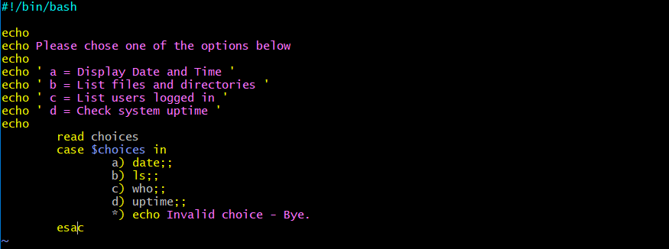

Then allow permissions
chmod 755 case-script.bash
./case-script.bash
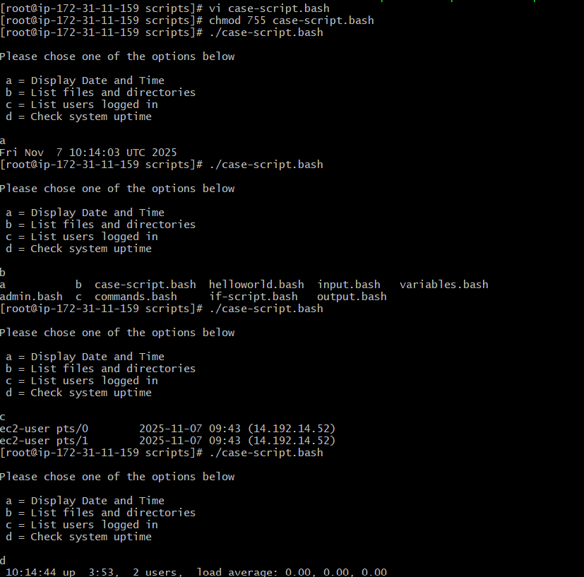
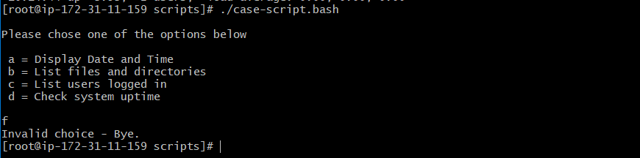

if I enter option other than what I have provided it will show
Invalid choice – Bye

This script will look at your current day and tell you the state of the backup
vi backup-script.bash
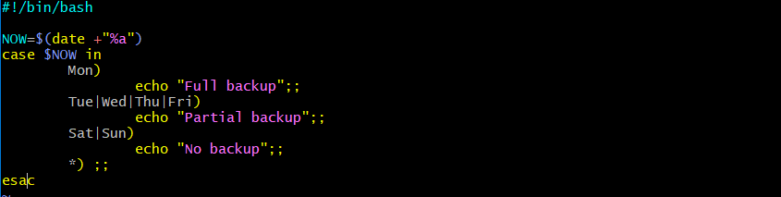
After allowing permissions
Chmod 755 backup-script.bash
./backup-script.bash


Current day script shows the partial backup state

do-while script

script to run for a number of times
vi do-while-script.bash
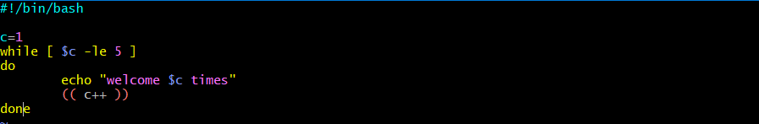
Allow permissions
chmod 755 do-while-script.bash
./do-while-script.bash
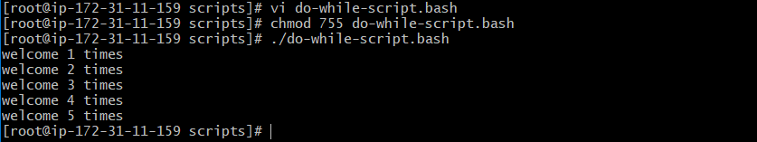
It will display welcome message 5-times , because we have written -le – less than 5 times

Script to run for a number of seconds
vi do-while-script.bash
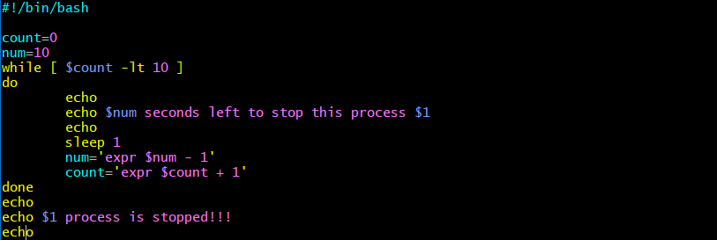
After that we allow permissions
chmod 755 do-while-script.bash
./do-while-script.bash

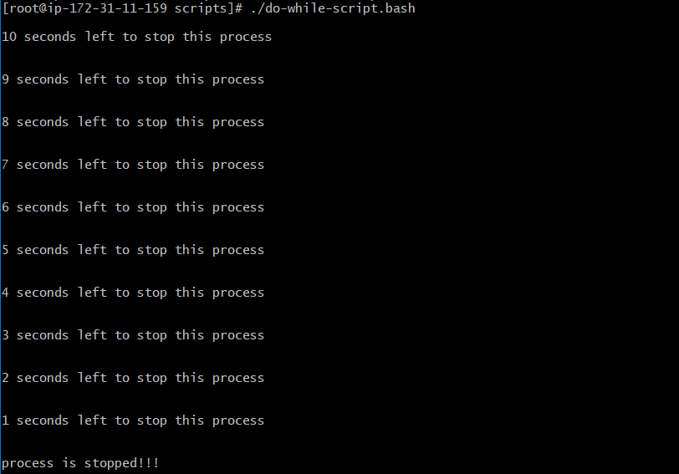

for loop scripts:
simple for loop output
vi for-loop.bash

After allowing permissions
chmod 755 for-loop.bash
./for-loop.bash
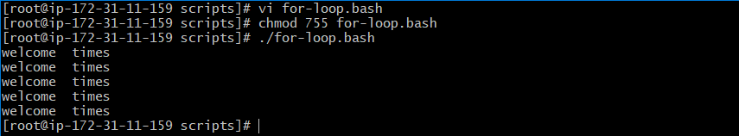

simple for loop output
vi for-loop.bash
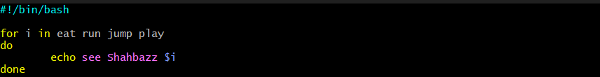
After allowing permissions
chmod 755 for-loop.bash
./for-loop.bash
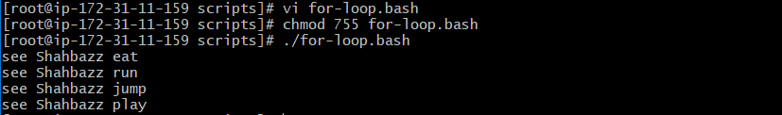

For loop to create 5 files named 1-5
vi for-loop.bash
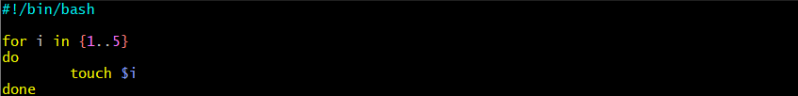
After allowing permissions
chmod 755 for-loop.bash
./for-loop.bash
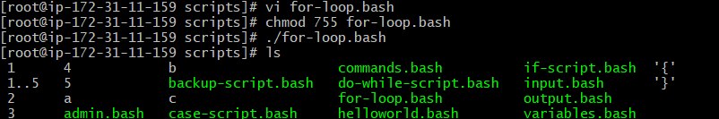
Files have been created from { 1 2 3 4 5 }

for loop to delete 5 files named 1-5
vi for-loop.bash
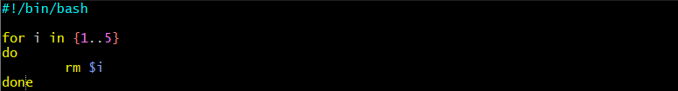
After allowing permissions
chmod 755 for-loop.bash
./for-loop.bash
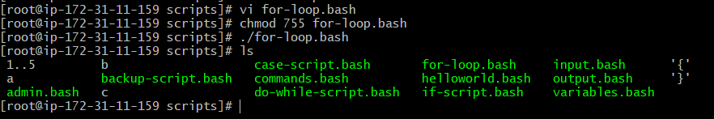
Files have been deleted from { 1 2 3 4 5 }

Specific days in for loop
vi for-loop.bash
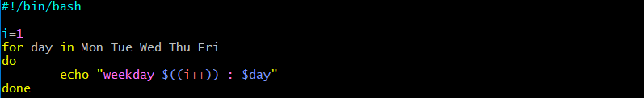
After allowing permissions
chmod 755 for-loop.bash
./for-loop.bash
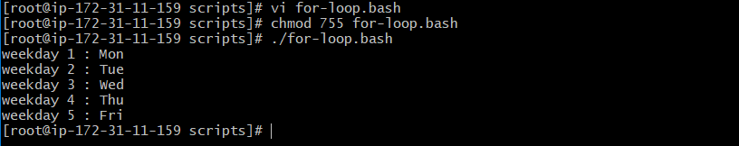

List all users one by one from /etc/passwd file
vi for-loop.bash
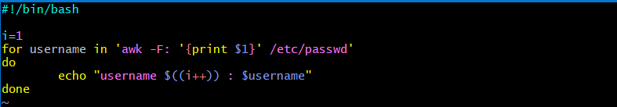
After allowing permissions
chmod 755 for-loop.bash
./for-loop.bash
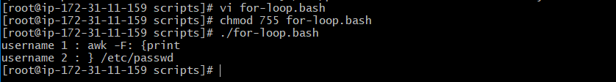

If-then scripts:
Check the variable
vi if-scripts.bash

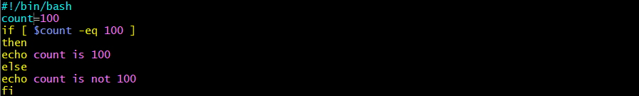

Then after that we need to allow permissions to this file
chmod 755 if-script.bash

./if-script.bash
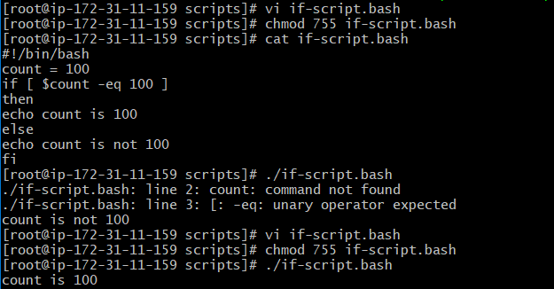

Check if a file error.txt exist
vi if-scripts.bash
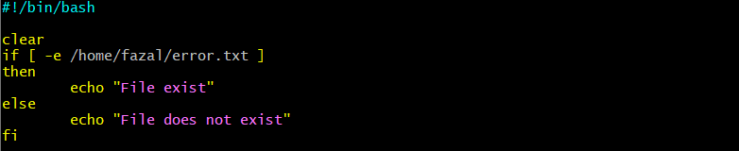

Then after that we need to allow permissions to this file
chmod 755 if-script.bash

./if-script.bash

Check if variable value is met
vi if-scripts.bash
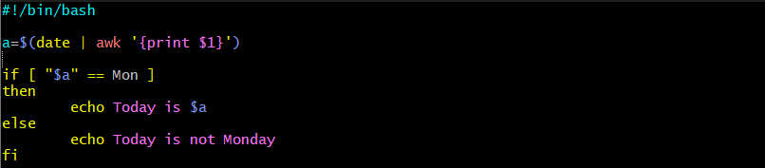
Then after that we need to allow permissions to this file
chmod 755 if-then.bash
./if-then.bash


Check the response and then output.
vi if-scripts.bash
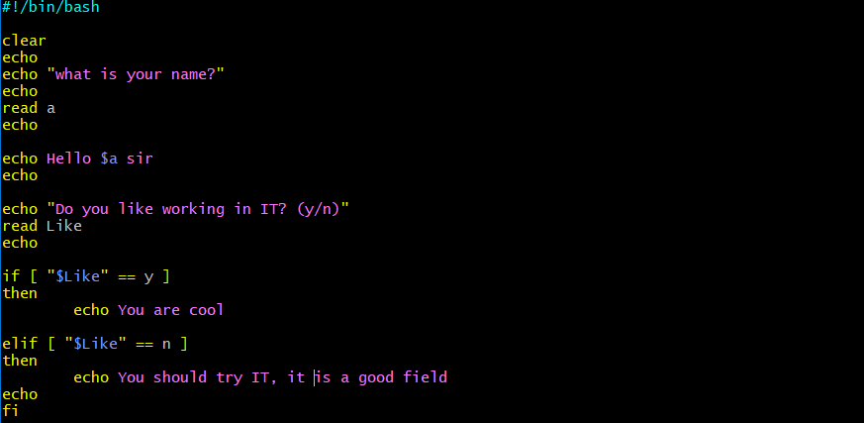

Then after that we need to allow permissions to this file
chmod 755 if-then.bash
./if-then.bash
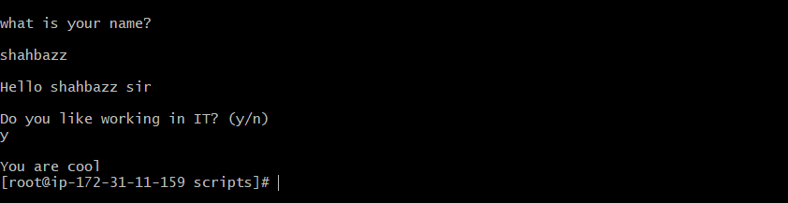
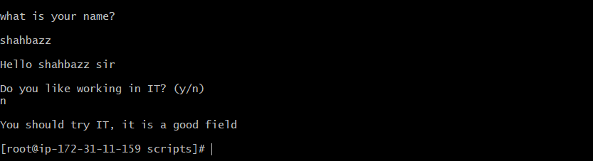

Other if statements
if the output is either Monday or Tuesday
if [ “$a” = Monday ] || [ “$a” = Tuesday ]
vi if-scripts.bash
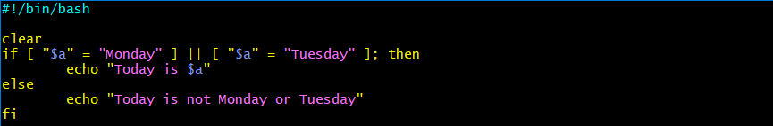
After allowing permissions to the file
chmod 755 if-scripts.bash
./if-scrpts.bash

Test if the error.txt file exists and its size is greater than zero
If test -s error.txt
vi if-scripts.bash
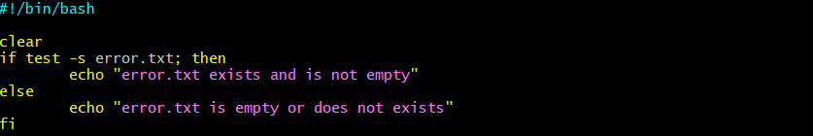
After allowing permissions to the file
chmod 755 if-scripts.bash
./if-scrpts.bash

if [ $? -eq 0 ] ----- if input is equal to zero (0)
vi if-scripts.bash
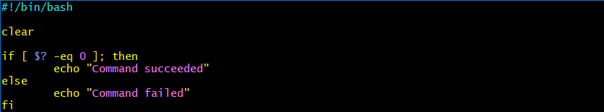
After allowing permissions to the file
chmod 755 if-scripts.bash
./if-scrpts.bash

If [ -e /export/home/filename ] ----- if file is there
vi if-scripts.bash
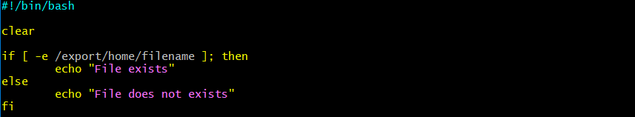
After allowing permissions to the file
chmod 755 if-scripts.bash
./if-scrpts.bash
If [ “$a” != “ ” ] ----- if variable doesnot match
If [ error_code != “0” ] ----- if file is not equal to zero (0)

Comparisons:
-eq equal to for numbers
== equal to for letters
-ne not equal to
!== not equal to for letters
-lt less than
-le less than or equal to
-gt greater than
-ge greater than or equal to

File operations:
-s file exists and is not empty
-f file exists and is not a directory
-d dirextory exists
-x file is executable
-w file is writable
-r file is readable

